Suicide Prevention and Response Expert Advisory Committee
Draft Terms of Reference
Background
The final report of the Royal Commission into Victoria’s Mental Health System (Royal Commission) recommended the Victorian Government facilitate a coordinated, evidence-informed, community-wide and whole-of-government approach to suicide prevention and response efforts.
To achieve this, the Royal Commission recommended establishment of a Suicide Prevention and Response Office, led by a State Suicide Prevention and Response Adviser, within the Department of Health. The Office will operate in government‑wide governance structures that encompass all government departments and relevant agencies. The Office will be responsible for:
- establishing a system‑based approach to suicide prevention and response
- co‑producing a new Suicide Prevention and Response Strategy for Victoria with people with lived experience of suicidal behaviour or bereavement by suicide
- driving implementation of the suicide prevention and response initiatives outlined in both the Royal Commission’s interim and final reports
- working closely with the Commonwealth Government to ensure suicide prevention and response efforts in Victoria are coordinated with, and complement, national approaches.
The Office will drive systemic and evidence-informed reform in collaboration with people with lived experience of suicidal behaviour, family members and carers, and people with lived experience of bereavement by suicide.
To support the whole-of-government approach, the Royal Commission recommended establishment of a new governance group – the Suicide Prevention and Response Secretaries’ Board Subcommittee – which encompasses all relevant government departments and agencies. The Subcommittee will be accountable for suicide prevention and response outcomes.
The Royal Commission also recommended establishment of new suicide prevention and response advisory structures – an Expert Advisory Committee and a Lived Experience Advisory Committee – to provide expert advice to the State Suicide Prevention and Response Adviser and Suicide Prevention and Response Secretaries’ Board Subcommittee. In recognition that lived experience expertise must be valued equally and integrated into all suicide prevention and response conversations, it has been agreed that these two committees are combined.
Purpose
The Suicide Prevention and Response Expert Advisory Committee is a core element of the new structures that will support suicide prevention and response efforts in Victoria. The Committee’s place in the broader suicide prevention and response architecture, as per the Royal Commission’s final report, is outlined at Appendix 1.
The Expert Advisory Committee will provide advice on evidence-informed approaches to suicide prevention and response, including how the Victorian Government best adopts a whole-of-government, community-wide, systems-based approach.
It will also provide advice on data and evidence to drive outcomes; how to uplift workforce and community capacity and capabilities; delivery of compassionate services that respond earlier to distress; groups that are disproportionately impacted by suicide; and existing frameworks, models or programs that can be built upon.
The Expert Advisory Committee will ensure that lived experience knowledge and insights are integrated into government decision-making, that diverse and intersectional perspectives of suicide prevention and response are valued and inform government policies and programs, and that lived experience is central to the oversight, monitoring and evaluation of suicide prevention and response efforts.
Roles and responsibilities
Key roles and responsibilities include:
Suicide Prevention and Response Secretaries’ Board Subcommittee
- Provision of advice and recommended actions to the Subcommittee on implementation of whole of government, system-wide suicide prevention and response efforts, including new and emerging evidence, and in relation to Royal Commission recommendations.
- The Subcommittee may seek advice from the Expert Advisory Committee on suicide prevention and response initiatives being undertaken by departments and agencies and integration of lived experience of suicide perspectives.
- The Chair or other members may be called to present at Subcommittee meetings.
State Suicide Prevention and Response Adviser
- Provision of advice and ongoing collaboration with the State Adviser and the Office in the development, implementation and evaluation of initiatives, including the new Suicide Prevention and Response Strategy and other Royal Commission recommendations.
- Ongoing advice in relation to the integration of lived experience of suicide perspectives across the Mental Health and Wellbeing Division and identification of further opportunities for collaboration and partnership.
All members will support Aboriginal communities’ and Aboriginal Community-Controlled Organisations’ right to practice self-determination, embed cultural safety and provide advice from an intersectional lens.
Membership
Executive Sponsor: Mental Health and Wellbeing Promotion Adviser
Chairperson: Co-chair arrangements with Lived Experience representative and State Suicide Prevention and Response Adviser
Membership
The Expert Advisory Committee will comprise of approximately 14 members with a minimum of six lived experience members (people with lived experience of suicidal thoughts and behaviour, carers and family members and people who have been bereaved by suicide). It will include a mixture of people appointed by position and by expression of interest:
- Lived Experience, including members who can represent and/or understand diverse perspectives, such as rural/regional Victorians (including farming communities), children and young people (including children in out of home care), veterans/ex-armed services, LGBTIQ+ communities, culturally diverse communities, people with disability and neurodiverse people, people in contact with the justice system, people living with/or experience with a mental illness or alcohol and other drug concern, family violence and elder abuse survivors.
- Aboriginal and Torres Strait Islander community representative/s (including Traditional Owners Corporations and Aboriginal Community Controlled Organisation)
- Youth representative
- Research/academia (suicide prevention, mental health and medical research)
- Non-government organisation delivering prevention, intervention, postvention or bereavement services including helplines and direct service delivery
- Victorian Chamber of Commerce and Industry
- School/education sector representative
- Clinical sector – Adult and Older Adult services
- Clinical sector – Infant, Child and Youth Services
Representatives from the Suicide Prevention and Response Office and the broader Mental Health and Wellbeing Division may attend meetings as observers or presenters to seek advice from the Committee and provide feedback.
At times, other government or external representatives may also attend as contributors, presenters or observers to supplement the advice of members.
Length of membership and recruitment
Members appointed by position are done so to ensure a wide mix of expertise.
Other members will be sought via an Expression of Interest process with consideration of diverse and intersectional representation of lived experience of suicide. Experience with policy and reform advocacy will be sought but also the ability to represent the views of a range of communities and lived experiences to shape system reforms.
Membership will be held for a period of 12 months and then a review will be conducted.
Members attending in their personal capacity (not associated with an organisation supporting mental health, health or suicide prevention efforts) will be reimbursed for their time.
Meeting process
Meeting agendas will be set in consultation with the co-Chairs.
Meetings will take place every two months for a period of 1.5 hours. Additional meetings may be called, or items circulated out-of-session, when there is a need for timely advice on suicide prevention and response matters.
There may also be communication outside of meetings to ensure members understand the issues, opportunities and achievements of the reforms.
Papers and agendas will be circulated by the secretariat approximately five business days prior to the meeting date.
All Expert Advisory Committee meeting papers are to be treated as confidential, unless otherwise stated.
Notes on language
- People may use their own words to describe their own experience
- Not everyone speaks each other's language
- Where appropriate, the same language and terms in the final and interim reports of the Royal Commission into Victoria’s Mental Health System will be used
- All members, presenters and observers are on a learning journey. Permission is given to support contributors to use accessible, inclusive and aligned language
- People’s explanation or sharing of their experience might change over time and in different contexts. They are true to them, regardless. This will mean that as people make sense of an evolving context, language may change in the context of immediate or different groups
- History has a strong role in the use of language and how it evolves. This is recognised and will be worked through in a safe and inclusive manner with all involved
- Language will change from beginning to end. This may mean a united language will be formed for effective collaboration over time and space will be given for this to happen.
Secretariat and communications
The Suicide Prevention and Response Office will provide secretariat support.
Amendments/variation
This Terms of Reference may be amended, varied or modified in writing, following consultation and agreement with Committee members.

Appendix 1 - Suicide prevention and response governance and advisory structures
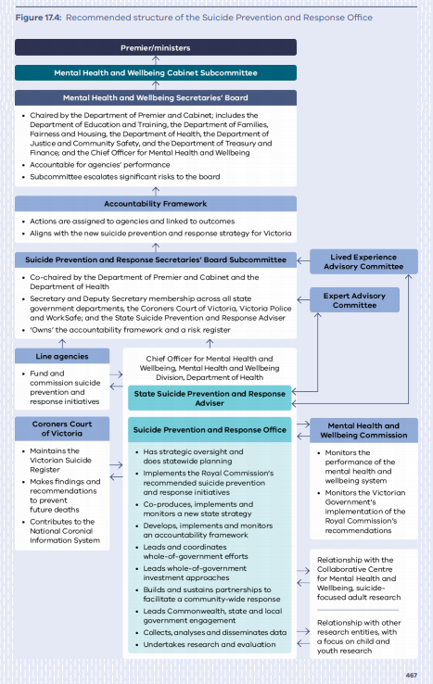
Source: RCVMHS Final Report, Chapter 2, p.467.
*Note: Decision to combine the Expert Advisory Committee and the Lived Experience Advisory Committee endorsed by the Mental Health and Wellbeing Promotion Interdepartmental Committee on 8 December 2021.

