Position Description
Lived Experience Representatives - Suicide Prevention and Response Expert Advisory Committee
OFFICIAL

Background
The final report of the Royal Commission into Victoria’s Mental Health System recommended the Victorian Government facilitate a coordinated, evidence-informed, community-wide and whole-of-government approach to suicide prevention and response efforts.
To achieve this, the Royal Commission recommended establishment of a Suicide Prevention and Response Office, led by a State Suicide Prevention and Response Adviser, within the Department of Health. The Office will operate in government-wide governance structures that encompass all government departments and relevant agencies. The Office will be responsible for:
- establishing a systems-based approach to suicide prevention and response
- co-producing a new Suicide Prevention and Response Strategy for Victoria with people with lived experience of suicidal behaviour or bereavement by suicide
- driving implementation of the suicide prevention and response initiatives outlined in both the Royal Commission’s interim and final reports
- working closely with the Commonwealth Government to ensure suicide prevention and response efforts in Victoria are coordinated with, and complement, national approaches.
The Office will drive systemic and evidence-informed reform in collaboration with people with lived experience of suicidal behaviour, family members and carers, and people with lived experience of bereavement by suicide.
To support the whole-of-government approach, the Royal Commission recommended establishment of a new governance group – the Suicide Prevention and Response Secretaries’ Board Subcommittee – which encompasses all relevant government departments and agencies. The Subcommittee will be accountable for suicide prevention and response outcomes.
The Royal Commission also recommended establishment of new suicide prevention and response advisory structures – an Expert Advisory Committee and a Lived Experience Advisory Committee – to provide expert advice to the State Suicide Prevention and Response Adviser and Suicide Prevention and Response Secretaries’ Board Subcommittee. In recognition that lived experience expertise must be valued equally and integrated into all suicide prevention and response conversations, it has been agreed that these two committees are combined.

Purpose
The Suicide Prevention and Response Expert Advisory Committee is a core element of the new structures that will support suicide prevention and response efforts in Victoria. The Committee’s place in the broader suicide prevention and response architecture, as per the Royal Commission’s final report, is outlined at Appendix 1.
The Expert Advisory Committee will provide advice on evidence-informed approaches to suicide prevention and response, including how the Victorian Government best adopts a whole-of-government, community-wide, systems-based approach.
It will also provide advice on data and evidence to drive outcomes; how to uplift workforce and community capacity and capabilities; delivery of compassionate services that respond earlier to distress; groups that are disproportionately impacted by suicide; and existing frameworks, models or programs that can be built upon.
The Expert Advisory Committee will ensure that lived experience knowledge and insights are integrated into government decision-making, that diverse and intersectional perspectives of suicide prevention and response are valued and inform government policies and programs, and that lived experience is central to the oversight, monitoring and evaluation of suicide prevention and response efforts.
Roles and responsibilities
Key roles and responsibilities include:
- Advice and recommended actions to key Victorian Government committees and departments/agencies, in relation to suicide prevention and response reforms
- Advice on systems-based approaches and evidence-informed suicide prevention and response initiatives
- Advice on how to implement intersectional, targeted and community-wide suicide prevention and response initiatives
- Advice in relation to the integration of lived experience perspectives and opportunities for collaboration and partnership
- Advice on required workplace, workforce and community capabilities to support long-term change.
*Please see attached draft Terms of Reference for more information.

About you
The Expert Advisory Committee will comprise of approximately 14 members with a minimum of six lived experience members (including people with lived experience of suicidal thoughts and behaviour, suicide attempt survivors, carers, supporters and family members and people who have been bereaved by suicide).
We are seeking a range of members that can represent diverse perspectives and have a range of skills and experiences.

- Lived Experience, including members who can represent and/or understand diverse perspectives, such as:
  - People living in rural and remote communities
  - children and young people (dedicated youth member)
  - veterans/ex-armed services
  - LGBTIQ+ communities
  - culturally diverse communities
  - People working in high-risk industries
  - People with disability and neurodiverse people
  - people in contact with the justice system
  - people living with/or experience with a mental illness or alcohol and other drug concern
  - family violence and elder abuse survivors.
- Aboriginal and Torres Strait Islander community representative/s (including Traditional Owners Corporations and Aboriginal Community Controlled Organisation)
- Research/academia
- Non-government organisation delivering prevention, intervention, postvention or bereavement services including helplines and direct service delivery
- Employers/business and industry
- School/education sector
- Clinical expertise

Do you have:
- experience in applying your lived experience and/or sector and professional expertise to influence and shape better suicide prevention and response interventions and outcomes?
- an ability to represent a diverse range of views and experiences and advocate for system-wide change and evidence-informed practice?
- an understanding of current systems, services and strategies relating to suicide prevention and response?
- an ability to communicate safely and meaningfully with people with lived experience and diverse sector and professional backgrounds?
All members will support Aboriginal communities’ and Aboriginal Community-Controlled Organisations’ right to practice self-determination, embed cultural safety and provide advice from an intersectional lens.
Time commitment
Meetings will take place every two months for a period of 1.5 hours. It is anticipated that meetings will be held virtually. However, this is open for discussion and agreement by members.
Additional meetings may be called, or items circulated out-of-session, when there is a need for timely advice on suicide prevention and response matters.
Please note that meetings may be held outside normal business hours (Mon-Fri, 9am-5pm) to accommodate Expert Advisory Committee members’ diverse requirements and other obligations.
There may also be communication outside of meetings to ensure members understand the issues, opportunities and achievements of the reforms.
Membership will be held for a period of 12 months and then a review will be conducted.
Remuneration
Members attending in their personal capacity (not associated with an organisation supporting mental health, health or suicide prevention efforts) will be reimbursed for their time.

Remuneration for participation is guided by the Department of Premier and Cabinet’s Appointment and Remuneration Guidelines, which set out scales for remuneration (guidelines-appointment-remuneration)
Supports
The following supports will be made available to Expert Advisory Committee members:
- Self-care and safety plan
- Pre-briefing and reflective space, access to other supports​ (e.g. mentoring, psychological support)
- Introduction to government and on-boarding supports to role of advisory committees​
- Probity and conflict of interest ​

Vaccination Policy
The Department of Health is committed to providing and maintaining a working environment which is safe and without risk to the health of its workers and clients. As it is an essential element of any role within the department that employees be able to attend work onsite and to do so safely, group members are required to be fully vaccinated against COVID-19. This requirement applies unless they have a medical condition which means they cannot be vaccinated against COVID-19. Therefore, the department will ask group members to provide proof of their COVID-19 vaccination status prior to commencing a role within the Terms of Reference Group.

How to apply
Interested applicants should fill in the accompanying application form and return to the State Suicide Prevention and Response Adviser at bailey.nation-ingle@health.vic.gov.au by 18 August 2022 (for commencement in early September).
If you have any questions about this role, please contact Vanessa Peters on Vanessa.Peters@health.vic.gov.au

Support lines
If you or a loved one need support, the following services are available:
- if you are in a situation that is harmful or life-threatening, contact emergency services immediately on Triple Zero (000).
- if you are not in immediate danger but you need help, call NURSE-ON-CALL on 1300 60 60 24
- for crisis support, contact Lifeline on 13 11 14 or at <lifeline.org.au>
- for support to address distress or thoughts of suicide, contact Suicideline on 1300 651 251 or at <suicideline.org.au>
- for support, contact Beyond Blue on 1300 224 636 or at <beyondblue.org.au>
- for Aboriginal and Torres Strait Islander people who need support, contact Yarning Safe N Strong on 1800 959 563 or at <vahs.org.au/yarning-safenstrong>
- for children and young people who need support, contact Kids Helpline on 1800 551 800 and at <kidshelpline.com.au> or headspace on 1800 650 890 or at <headspace.org.au/our-services/eheadspace>
- for LGBTQIA+ people who need support, contact Switchboard Victoria on 1800 729 367 (call), 0480 017 246 (text) and <support@rainbowdoor.org.au> (email)
- if you are looking for a mental health service, visit <betterhealth.vic.gov.au> or contact your local GP to find out about your options

Appendix 1 - Suicide prevention and response governance and advisory structures

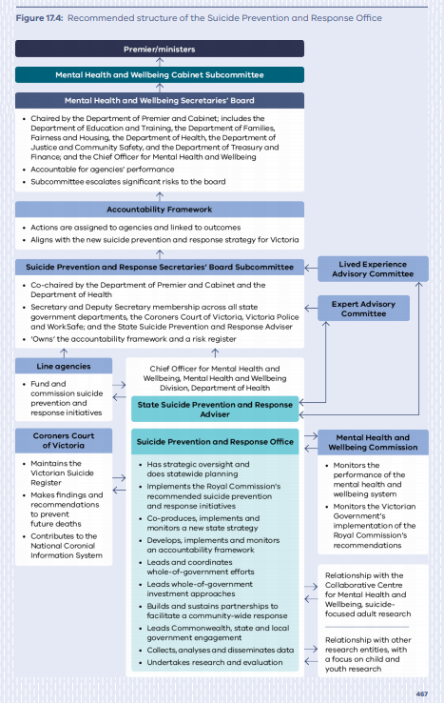
Source: RCVMHS Final Report, Chapter 2, p.467.

